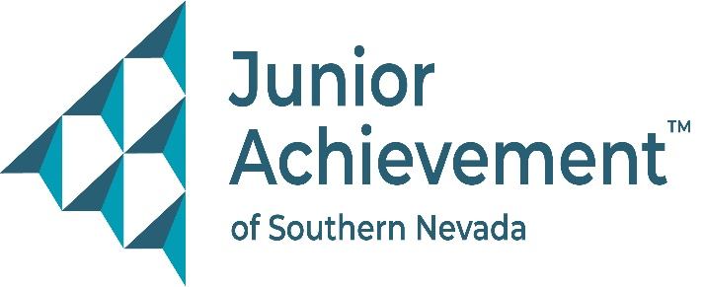
Date
FOR IMMEDIATE RELEASE:

Junior Achievement of Southern Nevada Welcomes Omar Hanson from Caesars Entertainment to Board of Directors


LAS VEGAS – Junior Achievement of Southern Nevada (JASN) is proud to announce the appointment of Omar Hanson, director of catering, conventions and events at the Horseshoe Las Vegas and Paris Las Vegas, to its board of directors. Before joining the board, he made significant contributions to the financial literacy nonprofit as a member of its marketing committee. Now his experience will be an invaluable resource to the broader organization.
Hanson has more than 15 years of experience in the hospitality industry. In his current role, he oversees a dynamic team responsible for planning and executing a wide variety of events, ensuring exceptional service and operational excellence. His specialties include food and beverage operations, banqueting and events management, sales and marketing, and guest relations – skills that directly align with JASN’s mission to inspire and prepare young people for economic success.
Hanson’s career trajectory began with a Bachelor of Science in International Hospitality Management from the ECOLE HÔTELIÈRE DE LAUSANNE in Switzerland. His education and professional journey have taken him to New York City, Washington, D.C., and Las Vegas, where he has held leadership roles at Mandalay Bay Resort & Casino, Bellagio, Caesars Palace, and multiple Caesars Entertainment properties.
“Omar’s extensive expertise in hospitality and event management, innovative ideas and strategic guidance make him an exceptional addition to our board of directors,” said Michelle Jackson, JASN president and CEO. “His knowledge and leadership have been instrumental in the planning and execution of our events. Whether we’re hosting programs at an external venue or welcoming guests to our state-of-the-art JA Inspiration Center, Omar’s strategic insight enhances our ability to create impactful experiences that benefit our students and community.”
About Junior Achievement of Southern Nevada
Founded locally in 1996, Junior Achievement of Southern Nevada, Inc. is dedicated to providing financial education to K-12 students and young adults with a curriculum including wants vs. needs, budget management to economic principals, workforce skills, credit and entrepreneurship. The completion of the new 40,000-square-foot Junior Achievement of Southern Nevada Inspiration Center will allow the nonprofit organization to impact more than 60,000 local youth. It is now the permanent site for capstone programs, Betty’s JA BizTown and JA Finance Park. Junior Achievement of Southern Nevada’s financial literacy mission is accomplished with the support of 285 businesses and 6,800 business role models, who help youth learn about the “business of life,” by helping bridge the gap between what youth learn in school and the real world. For more information visit https://jasnv.org/ and follow on Instagram and Facebook.

# # #

MEDIA CONTACT:
Nancy Katz, Purdue Marion & Associates, 702-349-0063 or nancy@purduemarion.com

